Standard Operating Procedure
Counting, and measuring zooplankton samples- aliquot method

Purpose
The purpose of this Standard Operating Procedure (SOP) is to ensure that accurate and consistent methods are used in identifying, counting, measuring, and archiving zooplankton samples. These procedures are designed to process samples collected with a Clarke-Bumpus Metered Zooplankton Net, Wisconsin Net, or Student Net.

Procedures
- Prepare the sample
- Have the field sampling datasheet for the sample handy, you will record numbers from this procedure on that datasheet.
- Empty the contents of a sample into a strainer of the same pore size as the net the sample was collected with (e.g., 153 micron). Collect the waste preservative into a beaker. Discard the waste preservative into an appropriate hazardous waste container (not in the sink!).
- Rinse the sample bag until there are no plankton left in the bag.
- Remove the label from the bag, and set aside to dry. If the label tears, replace it with a new one written in pencil on bond or write in the rain paper.
- Sample bag may be disposed in the trash.
- Using distilled water, rinse the contents of the strainer into a small beaker. Make sure that all of the plankton makes it into the beaker.
- Empty the contents of the beaker containing the plankton into a graduated cylinder (usually either a 10mL or 25mL cylinder). Measure the volume of the contents of the beaker. Empty all into a larger beaker (>250mL).
- Rinse the small beaker with distilled water, and measure the volume of this rinse water with the graduated cylinder. Be sure to rinse all of the plankton out of the small beaker into the graduated cylinder. Add contents of graduated cylinder to the large beaker with the rest of the sample.
- Use distilled water to rinse the graduated cylinder, recording the volume of water used. Add this water to the large beaker containing the rest of the sample.
- Continue diluting the sample until there are >50 animals per 1 mL aliquot, with at least 12 Daphnia/aliquot. Do not leave the sample so concentrated that you have trouble counting animals.
- Try to avoid over-diluting the sample; if you do, you must strain the water from the plankton and repeat this process.
- Record the total water dilution (mL) used in the sample’s data sheet. If you forget to do this, the sample will have to be re-processed.
- Draw and enumerate an aliquot.
- Stir the sample within the large beaker, using the Hensen-Stempel (H-S) pipette, to uniformly distribute the plankton.
- Then, stir in the opposite direction to suspend the mixture.
- Use the H-S pipette to collect a 1mL sub-sample of plankton (our H-S pipettes measure exactly 1mL).Quickly set the beaker down and take an aliquot by setting the H-S pipette on the bottom of the beaker and, while raising the pipette through the sample, release the plunger to draw water and Daphnia into the pipette. After drawing the sample, check to make sure there are no air bubbles in the pipette; air bubbles would decrease the amount of water and daphnia in the pipette.
- Release the sample into a Sedwick-Rafter cell and cover with a coverslip. It is best to place the sample slightly off center in the well of the slide.
- Using distilled water, rinse any daphnia that may be sticking to the pipette into the second beaker. Cover the beaker containing the diluted daphnia sample with a petri dish to prevent evaporation while counting and measuring Daphnia on your slide.
- Place the slide under the compound microscope and begin counting the number of each species you observe.
- You should normally use the 32x objective. Zoom in if necessary to get a closer look at an animal.
- At 32x on the grey Zeiss scope, it takes about 3.5 “passes” to witness the entire sample. When processing, be sure to “keep in your row”. Otherwise, you may double count some animals, and miss others.
- Measure up to 25 Daphnia of each species present; measure the first 25 individuals you encounter and identify (Figure 1). Depending on the study, it may be necessary to count the number of eggs you see inside female Daphnia. You should count but not measure Daphnia neonates.
- Once done with an aliquot, “dump” the sample back into the beaker containing the rest of the sample.
- Record the number of plankton witnessed on the appropriate data sheet.
- Prepare a second aliquot.
- Repeat again until 3 aliquots have been completed.

- Archiving samples
- Sieve the sample using the 153μ strainer. Be sure to remove all of the plankton from the beaker.
- Using distilled water, “move” the entire sample to one end of the strainer.
- Using 70% ethanol, rinse the sample through a funnel into a 20 mL scintillation vial. Be sure to remove all of the plankton from the strainer.
- Roll up the original label that you removed from the sample bag and place it into the vial, and tighten the cap.
- Store the sample vial with the rest of the zooplankton samples from the same reservoir.

Health and Safety Considerations
- Field samples are preserved in either 5-10% sugared, buffered formalin or 70% ethanol. Both preservatives are potential health hazards.
- Wear gloves and eye protection when handling zooplankton samples.
- Handle samples under the fume hood and use the fume tube when examining samples under the microscope.
- Ethanol is extremely flammable- keep away from heat, sparks and flame.
- Dispose of waste preservatives according to CSU Environmental Health Services protocols.

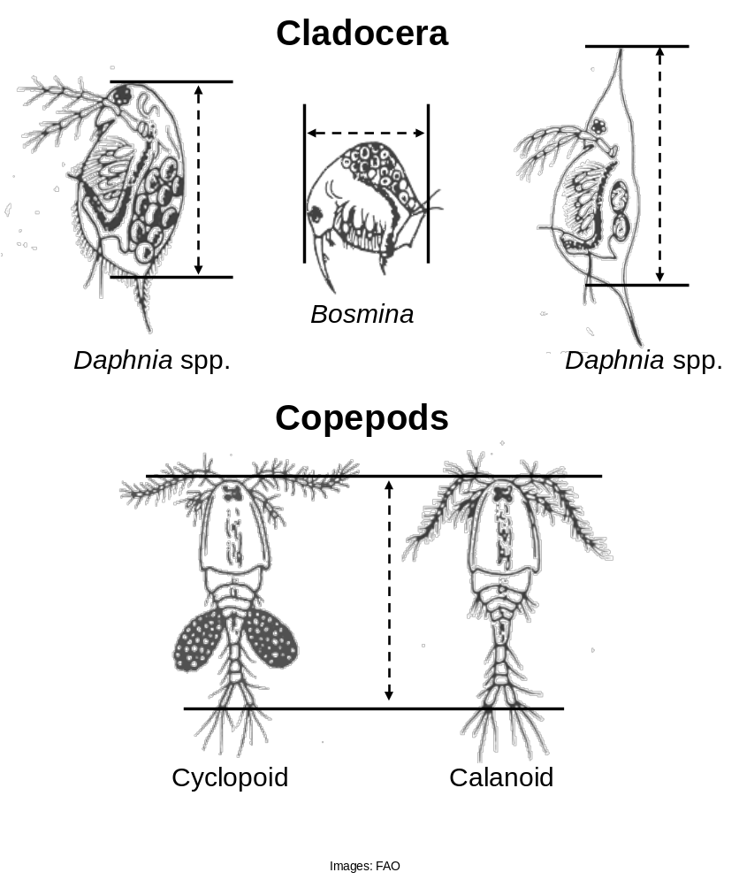
Figure 1. Measurement protocol for zooplankton processed in CSU Fisheries Ecology Laboratory.

